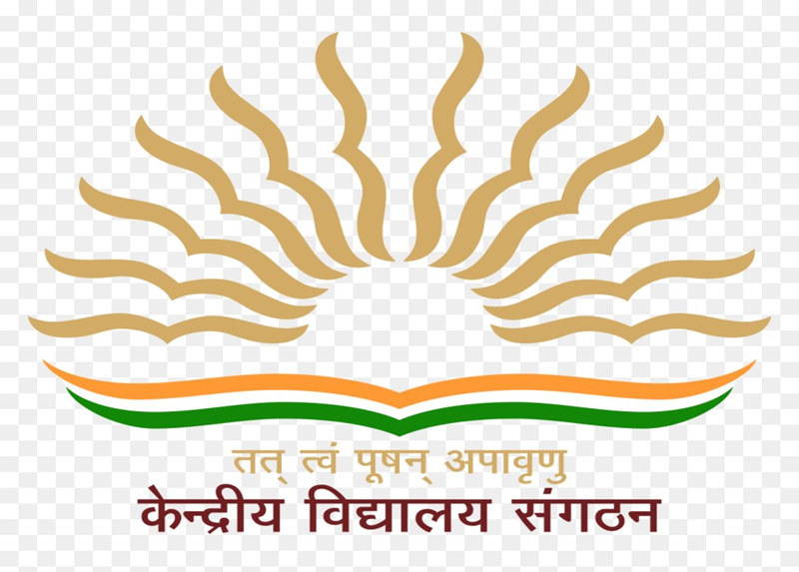

**ANNUAL ACADEMIC CALENDER** 2021-22

**KENDRIYA VIDYALAYA NO.2,**

**VASCO DA GAMA, GOA**

**MISSION**

**“Green School- Clean School**

**&**

**Conserve Natural resources “**

**VIDYALAYA WEEK WISE ACTIVITIES**

|  |  |  |  |  |  |
| --- | --- | --- | --- | --- | --- |
| **MONDAY** | **TUESDAY** | **WEDNESDAY** | **THURSDAY** | **FRIDAY** | **SATURDAY** |
| **EK BHARATH SRESHTH BHARATH (EBSB)** | | | | | |
| **VIRTUAL ASSEMBLY**  TALKING HOUR –  Latest News, Important events etc of the partnering state |  | Bhasha Sangham |  | Quiz/ Question and answer session | Pledge on Swachhata/ Single use of plastic/ water saving/ natural unity in the language of the partnering state |
| **ACADEMICS** | | | | | |
| JOYFUL LEARNING  CLASSES :  1-12 | AEP BASED LAERNING APPROACH    CLASSES :  8-12 |  |  |  | BAGLESS PERIODS/ACTIVITIES  CLASSES :  1-8 |



**LIST OF ACTIVITIES**

1. Welcome and Beginning of New Academic Session
2. Registration for Class 2nd And Above as Per Vacancy Available
3. Verification of UBI Data and Collection of Fee For 1st Quarter
4. Introduction of Club Activities.
5. Meeting of Rajbhasha Hindi Committee.
6. CBSE- Joining Google Class room for Free online Training Programme
7. CBSE Academic Unit – Providing links on CBSE Academic Portal for Secondary and Senior School Curriculum 2021-2022 to download

(<http://cbseacademic.nic.in/curriculum_2022.html> )

1. Internal Assessment Test for the classes 9-12
2. Campaign - Fight against Covid 19 and Awareness on Covid 19 Approapriate Behaviours.
3. Fit India Movement -
4. “We Fit-India Fit “Awareness campaign
5. “Azadi Ka Amritotsav India” @75 activities-Words Picture making
6. Azadi Ka Amrit Mahotsav activities – Activities to mark India’s Civil Disobedience Movement (Dandi March)
7. Ganga Quest
8. Updation of PISA Portal.
9. NEP based Academic Planning- WEBINAR.

# 

**LIST OF ACTIVITIES**

1. Learning by Doing Activities : Integrated Learning Approach

Assigning Holiday Home works which develops interest in subject , social attitude, creativity and Environmental awareness.

1. Summer Vacation – Vidyalaya Closes for Summer Vacation.
2. Manodarpan and Stress Management activities by Teachers.
3. Fit India Movement –
4. Fitness with Yoga
5. “Azadi Ka Amritotsav India” @75 activities-Mapping important historical events from 1857-1947 preparing a diary/Scrapbook/Wall magazines/PPT



**LIST OF ACTIVITIES**

1. Environmental Day Celebration- WEBINAR
2. Eco Club and Energy Club activities – Plantation and Energy conservation programs
3. NEP Based Lesson Plan preparation and submission by teachers.
4. School Re-opening.
5. Internal Assessment 1 – Assignment/Quiz/Experiments ( Class 1-12)
6. Fit India Movement -
7. “Azadi Ka Amritotsav India” @75 activities-Mapping important historical events from 1857-1947 preparing a diary/Scrapbook/Wall magazines/PPT
8. Yoga Month- Celebration of Yoga Day with Age appropriate Yoga activities
9. RRC - Online FORMING THE RRC ADVISORY COMMITTEE AT INSTITUTIONAL LEVEL and Planning of the RRC Yearly Online Activity Plan after Approval of Goa SACS
10. Updation of UDISE Data
11. Verification of UBI data
12. Investiture Ceremony for the House and School Captains/Students Council.



**LIST OF ACTIVITIES**

1. Collection of fees for second quarter through UBI
2. First Term Assessment - Periodic Test 1
3. Environment /Plantation/Book Week/Van Mahotsova
4. RRC- Online Inauguration and Training on HIV/ AIDS & RRC- 2 Hour Session conducted by Medical Officer only and Slot of Positive Speaker Session.
5. Collection and Donation of Old books to Vidyalaya ( Classes 2-12)
6. Fit India Movement – Indigenous sports
7. “Azadi Ka Amritotsav India” @75 activities- Indigenous sports of Pre-Independence

(Drama/Theatre/Role play)

1. Expert talk by P&HE on topic “ Indigenous Sports and its Importance”
2. Organization of indigenous sports activities.
3. Ek Bharat Shrestha Bharat and Science Exhibition at school level
4. Publication of Vidyalaya Patrika (before 31st July for the previous academic session)
5. Meeting of Rajbhasha Committee.



**LIST OF ACTIVITIES**

1. Independence Day Celebration.
2. RRC - International Youth Day Online Activity
3. Fit India Movement – Kick Start India @75
4. First week - Curtain Raiser

Expert talk on 75th Independence Day of India by Senior Citizen or Retired/Jawan Officer from Defence of the nearby locality/eminent personality.

1. Second week - Independence Day Run (Conduct walk by the Senior citizens )
2. Third & Forth week – Fit India Mental Fitness Week

Essay Writing competition (India-The Super power in Sports@75) and Quiz competition on Independence Day

1. “Azadi Ka Amritotsav India” @75 activities-- Freedom Fighters/Martyrs,their life &contributions(Drama/Theatre/Role play)
2. Internal Assessment 2- Projects/Assignments/Experiments ( Classes 1-12)
3. Collection of Tetrapacks (Classes 1-12)
4. Sanskrit Week Celebration
5. Ek Bharat Shrestha Bharat Parv
6. Conduct of VMC meeting



**LIST OF ACTIVITIES**

1. Teachers Day Celebration
2. EBSB –
3. Essay competition among students in the language of partnering state
4. Identification/ Translation similar proverbs in the language of partnering state
5. Fit India Movement – Freedom Run India@75
6. First week – Primary ( Freedom Run/Walk by Students, Parents and Teachers )
7. Second week-Secondary( Freedom Run/Walk by Students, Parents and Teachers )
8. Third Week & forth week – Senior secondary ( Freedom Run/Walk by Students, Parents and Teachers )
9. “Azadi Ka Amritotsav India” @75 activities-

Aligning the beliefs/ideology/-with various movements/events/events that lead to Independence.

1. Maths Olympiad
2. Projects for NCSC and JNNSMEE
3. Hindi Pakhwada
4. Swachtha Pakwada
5. Awareness campaign to avoid Plastic Bags and Making of Cloth Bags.
6. Autumn Break stress free assignments-

Internal Assessment 3- Projects/Assignments/Experiments (Classes 1-12)

1. Conduct of Class wise Parents-Teachers Meeting



**LIST OF ACTIVITIES**

1. Gandhi Jayanti Celebration/Grand Parent’s Day.
2. EBSB-

(i) Webinar on culture, history tradition of the partnering state

1. State Day Celebration - Cultural competition folk/ dance/ songs music of the partnering state (Online Presentation)
2. Fit India Movement- Fit India Plog Run by students,parents and Teachers
3. India’s 100 years Netaji’s & Gandhiji’s ideas
4. “Azadi Ka Amritotsav India” @75 activities-Transforming India and Land mark policies (Seminars & Webinars)
5. Collection of fees for third quarter through UBI
6. Vigilance Awareness Week (ends 31st),
7. Celebration of Rastriya Ekta Diwas
8. Meeting of Rajbhasha Committee
9. Conduct of National Children Science Congress.
10. Internal Assessment 4- Projects/Assignments/Experiments ( Classes 1-12)
11. Best Out of Waste Practice.



**LIST OF ACTIVITIES**

1. Children’s Day Celebration.
2. EBSB - Literary Fest- Poetry recitation/ extempore /Any creative activity
3. Fit India Movement –
4. Fit India Week – Eat Right Campaign (Expert talks, Lunch on the Day activity)
5. “Azadi Ka Amritotsav India” @75 activities-

The constitution of India:- the amendments towards realizations of equality & equity with special reference to education.(Seminars ,symposium & Debates)

1. National Education Day celebration.
2. Celebration of Constitution Day (26th Nov.)
3. Celebration of Communal Harmony Week.
4. First Term Assessment- Half Yearly Examination



**LIST OF ACTIVITIES**

1. Commemmeration of World AIDS Day- Awareness campaigns by AEP committee and RRC
2. EBSB - Video conferencing with students of partnering state
3. Fit India Movement –
4. Fit India Week –
5. Eat Right Campaign (Expert talks, Lunch on the Day activity)
6. “Azadi Ka Amritotsav India” @75 activities-

The constitution of India:- the amendments towards realizations of equality & equity with special reference to education.(Seminars ,symposium & Debates).

Visit of students to place of Historical places /Border areas/Seema Darshan in view of inculcating Patriotism.

1. National Energy Conversation Day (14th December)
2. K.V.S. Foundation Day (15th December)
3. Conduct of VMC meeting
4. Winter Break –

Internal Assessment 5- Projects/Assignments/Experiments ( Classes 1-12)

EBSB Activity during Winter Break - Translation of popular regional Folk tales and poems of the partnering state



**LIST OF ACTIVITIES**

1. EBSB - State project note book of partnering state
2. National Youth Day Celebration under RRC
3. RRC Report Submission
4. Republic Day Celebration
5. Fit India Movement- Fit India Cyclothon @block level
6. Fit India Festive Special (EBSB)

First & Second week

1. Walking minimum 5 kms in the Historical places near the border.
2. Writing reports on the India’s Freedom Struggle.

Third & Forth week – Cyclothon

1. “Azadi Ka Amritotsav India” @75 activities-

Photography Competition- Independence as seen through the Lens

1. Second Term Assessment : Periodic Test 2
2. Meeting of Rajbhasha Committee.
3. Pre Board II Examination for Classes 10 and 12.



**LIST OF ACTIVITIES**

1. EBSB - State project note book of partnering state
2. Notification and registration for admission to class 1st and other classes.
3. Conduct interview for contractual appointments.
4. Conduct of VMC meeting in first week.
5. Fit India Movement-
6. Fit India Festive Special (EBSB)
7. Cyclothon
8. “Azadi Ka Amritotsav India” @75 activities-

Collage Competition- Independence as seen through the Images /reports

1. Cubs and Bulbul Utsav / celebration of Thinking Day.
2. Health check up
3. Online admission starts.
4. Revision Tests for the classes 1-9 and Class 11.
5. Pre Board II Examination for Classes 10 and 12.



**LIST OF ACTIVITIES**

1. Board Exam and Session Ending Examination for all classes.
2. EBSB - School Magazine Vidyalaya Patrika ( e- Magazine)
3. Stress Free campaign
4. Academic Planning for the Session 2022-2023
5. Declaration of the SEE results.
6. Admission as per KVS Schedule.