KENDRIYA VIDYALAYA NO-2, VASCO,GOA
2023-2024
BALVATIKA III
Committee Formation
Date: 06-07-2023
Balvatika meeting has been conducted on 06-07-2023 and Committee formed on the same date. Details are as follows;
Chairperson: Mr.C.B.Tiwari (Principal IC)
Members:
- Mrs.Priti Sachdeva (HM)
- Mrs.Sudha Yadav (PRT)
- Mrs.Sheeba.K.M (PGT Biology, ECCE Convenor)
- Mrs.Mridula Nagda (PRT Music)
- Mrs.Meera Kumari Meena (TGT Art Ed)

Purchase of Items:
As per the decision of the Committee, Mrs.Sheeba.K.M, Mrs.Sudha Yadav, Mrs.Mridula Nagda purchased the items such as Floor mat, Curtains, as per KVS norms. Mrs.Meera Kumari Meena and her team of Students done the art work of Balvatika room.

Date : 31-07-2023
Invitation
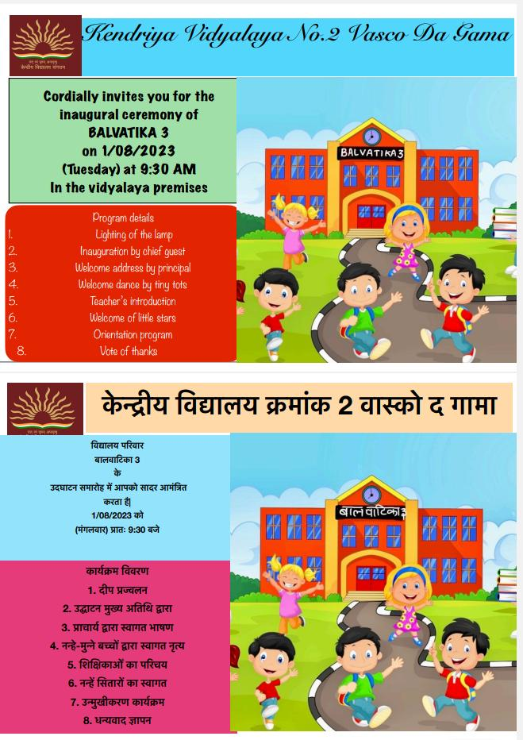

DATE : 01-08-2023
INAUGURATION
REPORT ON WELCOME OF TINY –TOTS IN BALVATIKA -3
It is our privilege that we were among the few chosen ones to start Balvatika-3 in our Vidyalaya.Today,01-08-2023 we had the welcome of tiny-tots in balvatika -3 along with an orientation of parents of these tiny-tots.
The day began as usual with morning assembly. We had invited the parents and students at 9.30am on 01.08.2023 .Sharp at 9.30am we made our children of class 1 to stand alongside the entrance with colourful balloons in their hands to welcome their brothers and sisters of Balvatika -3.All the class 1 children had come in fancy dress so the surrounding was very colourful. The little ones who were soon welcomed with a balloon each in their hands which were handed over by their elder brothers and sisters who were all full of smiles. A proper seating arrangement was done for the parents and little ones in the assembly ground. Once they were made to sit comfortably our program started, firstly with lighting of the lamp and a soothing prayer alongside. This was followed by an inaugural ceremony by unveiling the curtains from the banner of ‘BALVATIKA-3’ by our incharge principal, Mr. C.B.Tiwari and our incharge headmistress, Mrs. Sudha Yadav. Anchoring was done by Mrs.Ronika one of our Primary teacher. After the inaugural we had a welcome speech by our incharge principal.Now was the time for a cultural program. Primary students of classes 1 to 5 presented a beautiful welcome dance prepared by our music teacher Mrs. Mridula Nagda & Mrs. Mani Prabha had been a great support in assisting music teacher in every way possible. The dance was so lively and colourful that our tiny-tots thoroughly enjoyed watching. Soon after the welcome dance we had an introduction of our Balvatika teachers; Mrs., Jyoti Bandi and Ms. Sana Shaikh. We also introduced the care giver of Balvatika, Mrs. Geeta Guru.After which a formal welcome of every child of balvatika was done by calling them on the stage and honouring them with a welcome badge and a sweet.Principal, headmistress and all the primary teachers took turn to put badges and give the sweets to children.We also had our senior PGT –Biology, Mrs. Sheeba.K.M. along with us from the beginning of the program encouraging and motivating each one of us throughout the function. She too contributed in the program by giving several suggestions. Our Art teacher Mrs.Meera Meena also helped us a lot. She along with her team of students got the Balvatika room well decorated. Flooring, curtains, table and chairs were looked after by our Music teacher and our incharge principal. Decoration on the stage was seen by our Primary teachers Mrs. Priyanka and Mrs. Bhuvaneshwari. Mr. Surali Ram and Mr. Haresh looked after the seating arrangements. Mr. Haresh also contributed a lot in setting up the projector and screen for the power point presentation. Mrs. Medha prepared the ppt and carried out photography throughout the function. Mrs. Pratibha and Santoshree looked after the refreshment of parents. Each and every Primary teacher along with our sub-staff Mr. Prahlad and Mr. James worked together as a team to put out the best.
The most important aspect of this day was the orientation of the parents. Soon after the welcome of students of balvatika our incharge headmistress took an orientation of parents along with a power point presentation. A xerox copy of important general instructions were given to each parent member for their reference. Once the orientation was over we had a short vote of thanks by Mrs. Medha Sharma. There was refreshment for parents which included tea and biscuits. The children were asked to move in a line to their class – Balvatika 3 along with their parents to have a look of their lovely class and to know where the class is located. Ribbon cutting was done at the entrance of the class by our incharge principal and headmistress.The tiny -tots simply loved their class, we could make out from their bright and happy faces. Their class seemed so colourful with beautiful coloured tables and chairs. There was an activity area in one corner with lots of play items, toys, games, shapes, numbers, alphabets, puppets etc. The class was beautifully decorated with charts , wall paintings, wall hangings, masks etc. The board was well designed with colourful chalks.
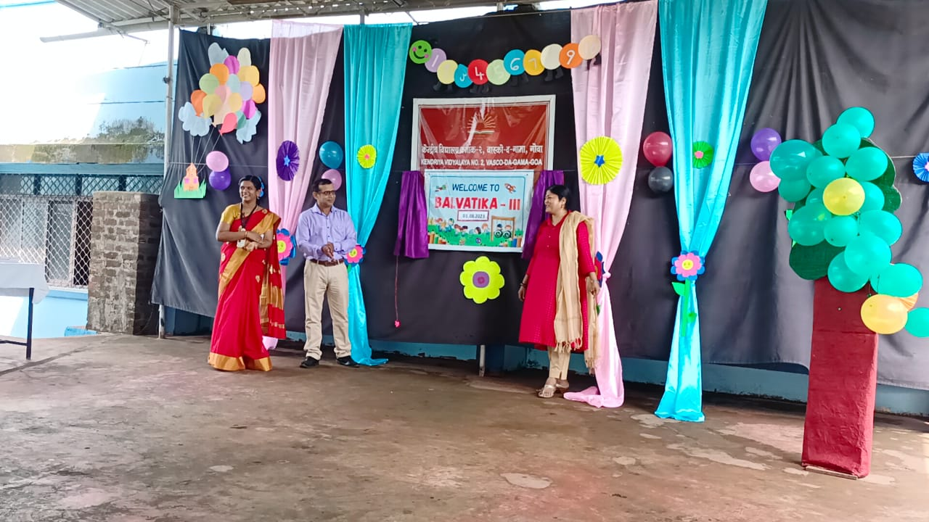

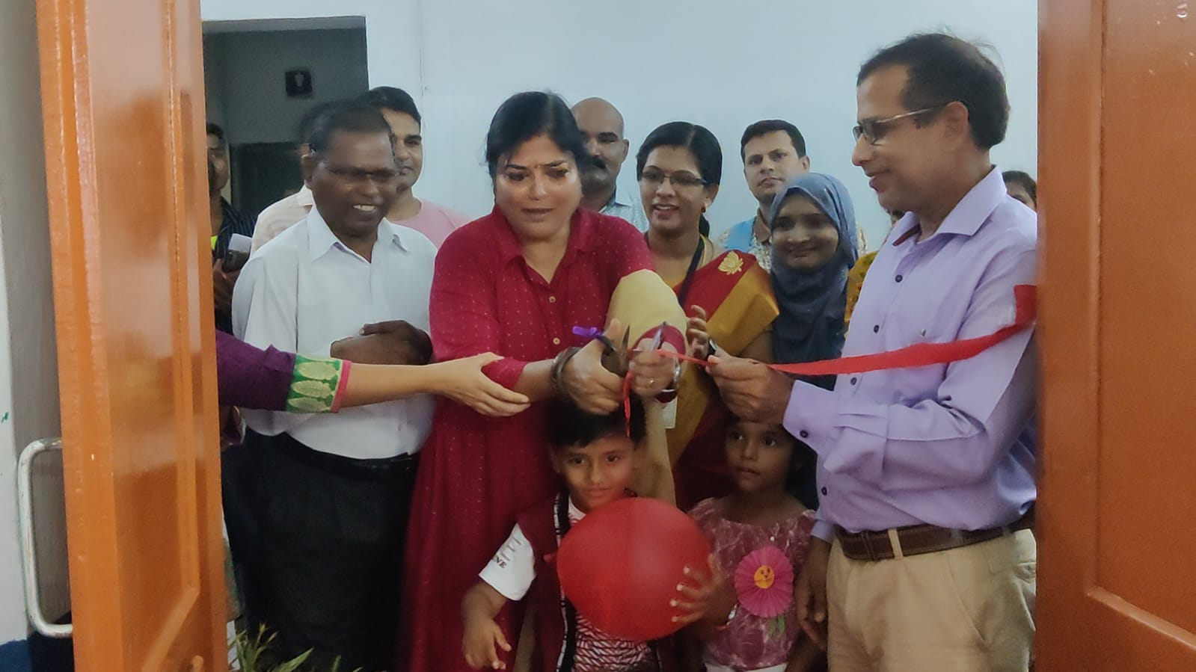
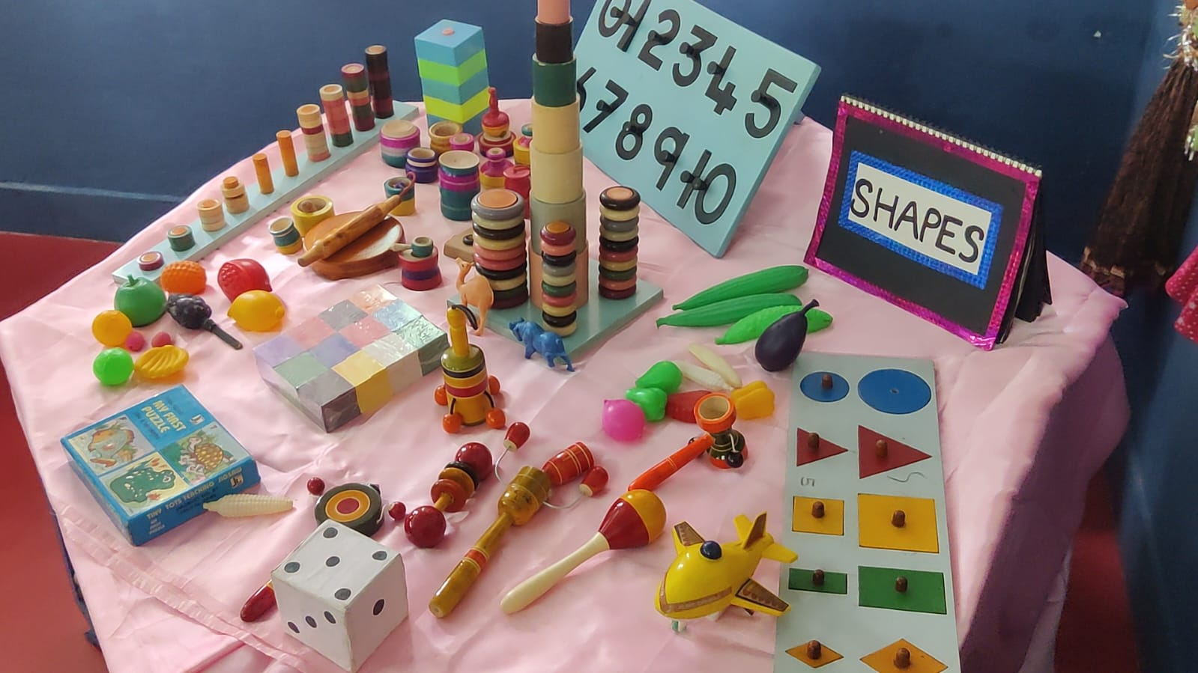
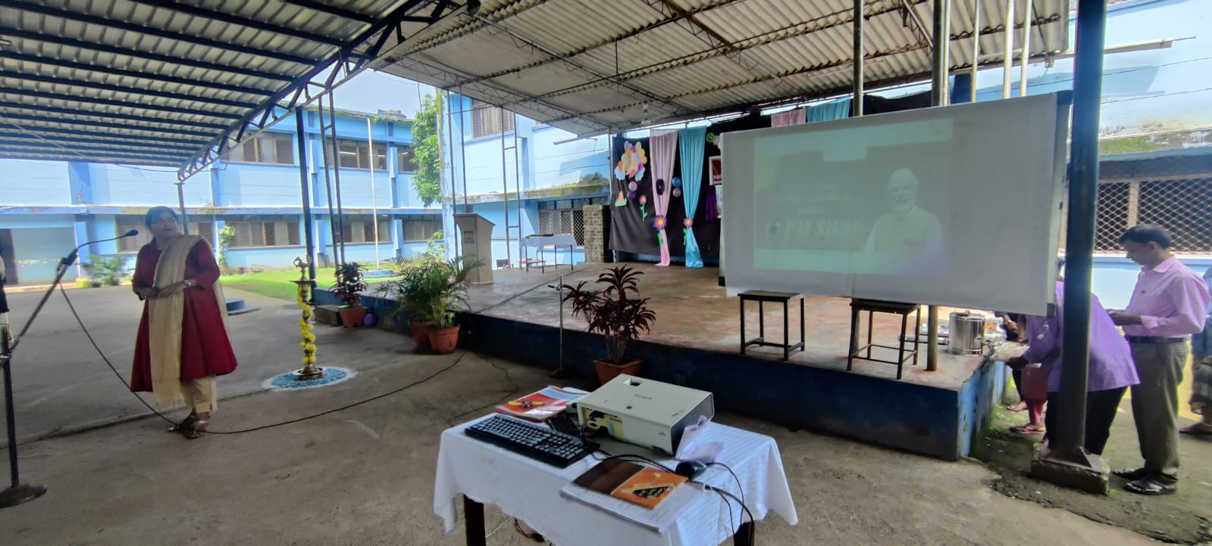
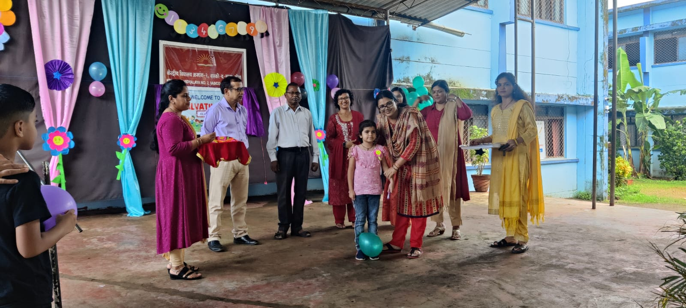
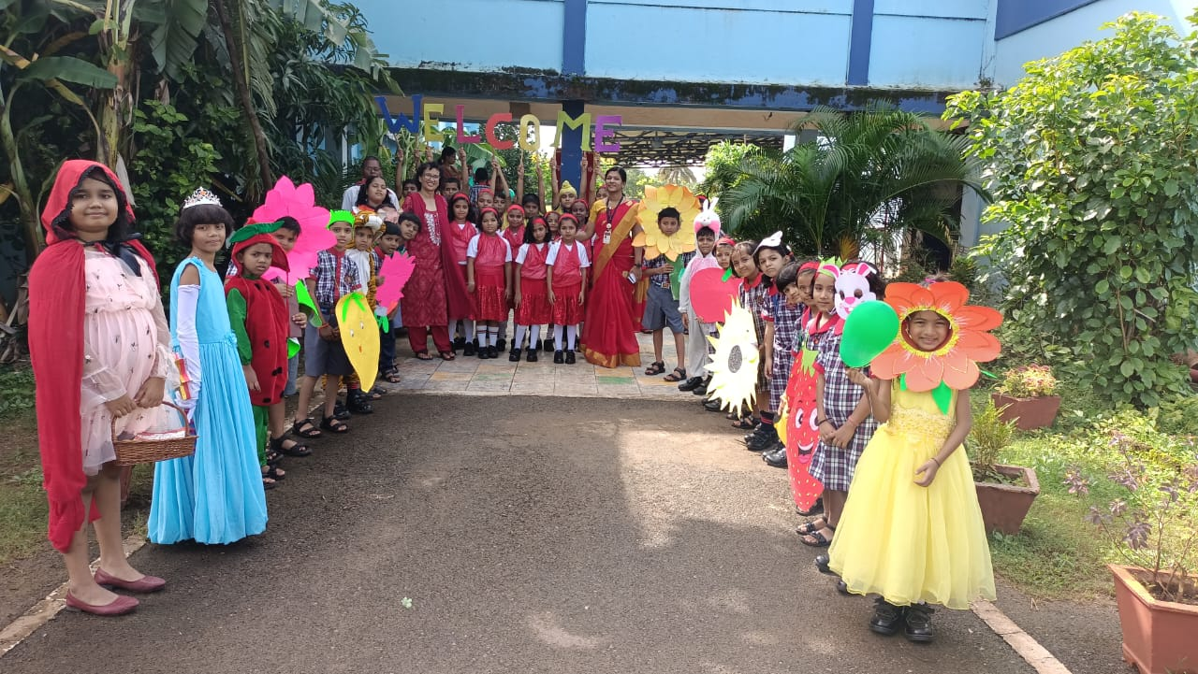
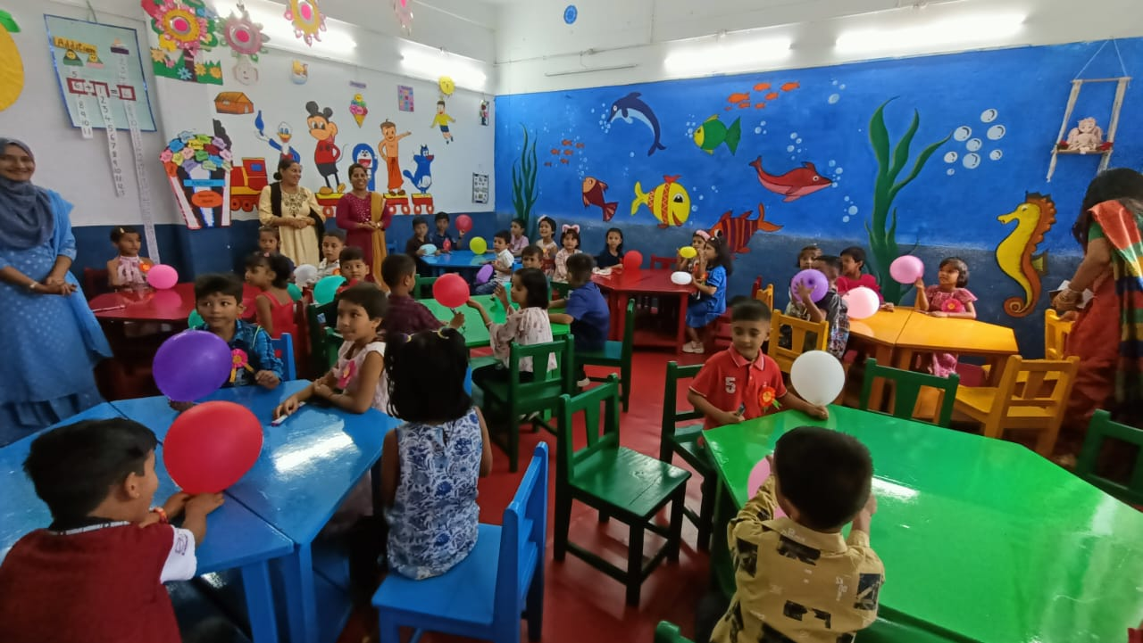
With the viewing of beautiful Balvatika class by children, parents and staff our first day of Balvatika ended with a happy note. I can now say the program was a grand success under the able guidance of our incharge principal Mr. C.B Tiwari and a complete team effort of our enthusiastic teachers along with other family members of the Vidyalaya.

